**Chapter-9**

**Introduction to BIOS**

## **1.0 Introduction**

The BIOS tells the operating system in your computer how to boot up, where to load everything, what to load, what’s memory and CPU are present and much more. The term BIOS (Basic Input/output System) was created by Gary Kildall and first appeared in the CP/M operating system in 1975, describing the machine-specific part of CP/M loaded during boot time that interfaces directly with the hardware. (A CP/M machine usually has only a simple boot loader in its ROM.)

Versions of MS-DOS, PC DOS or DR-DOS contain a file called variously "IO.SYS", "IBMBIO.COM", "IBMBIO.SYS", or "DRBIOS.SYS"; this file is known as the "DOS BIOS" (also known as the "DOS I/O System") and contains the lower-level hardware-specific part of the operating system. Together with the underlying hardware-specific but operating system-independent "System BIOS", which resides in ROM, it represents the analogue to the "CP/M BIOS".

With the introduction of PS/2 machines, IBM divided the System BIOS into real- and protected-mode portions. The real-mode portion was meant to provide backward compatibility with existing operating systems such as DOS, and therefore was named "CBIOS" (for "Compatibility BIOS"), whereas the "ABIOS" (for "Advanced BIOS") provided new interfaces specifically suited for multitasking operating systems such as OS/2.

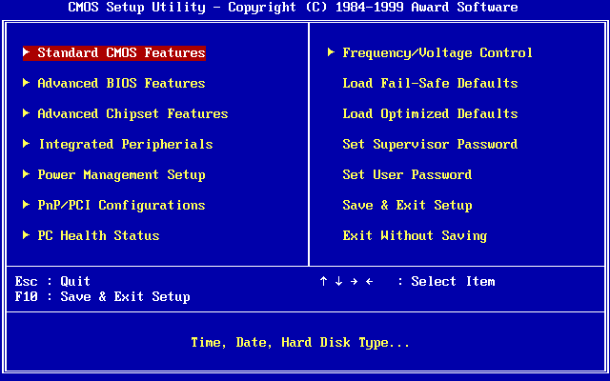

**Figure 1. BIOS setup screen**

The BIOS of the original IBM PC XT had no interactive user interface. Error codes or messages were displayed on the screen, or coded series of sounds were generated to signal errors when the power-on self-test (POST) had not proceeded to the point of successfully initializing a video display adapter. Options on the IBM PC and XT were set by switches and jumpers on the main board and on peripheral cards. Starting around the mid-1990s, it became typical for the BIOS ROM to include a "BIOS configuration utility" (BCU) or "BIOS setup utility", accessed at system power-up by a particular key sequence. This program allowed the user to set system configuration options, of the type formerly set using DIP switches, through an interactive menu system controlled through the keyboard.

In the interim period, IBM-compatible PCs‍—‌including the IBM AT‍—‌held configuration settings in battery-backed RAM and used a bootable configuration program on disk, not in the ROM, to set the configuration options contained in this memory. The disk was supplied with the computer, and if it was lost the system settings could not be changed. The same applied in general to computers with an EISA bus, for which the configuration program was called an EISA Configuration Utility (ECU).

A modern Wintel-compatible computer provides a setup routine essentially unchanged in nature from the ROM-resident BIOS setup utilities of the late 1990s; the user can configure hardware options using the keyboard and video display. Also, when errors occur at boot time, a modern BIOS usually displays user-friendly error messages, often presented as pop-up boxes in a TUI style, and offers to enter the BIOS setup utility or to ignore the error and proceed if possible. Instead of battery-backed RAM, the modern Wintel machine may store the BIOS configuration settings in flash ROM, perhaps the same flash ROM that holds the BIOS itself.

## **2.0 BIOS ROM**

BIOS software was stored on a non-volatile ROM chip on the motherboard usually in a socket which was removable. In computer systems, the BIOS contents were stored on a flash memory chip mostly an *Electrically Erasable and Programmable ROM (EEPROM*), but now in *flash memory*, which enables firmware updates to be performed electronically. This allows BIOS software to be easily upgraded to add new features or fix bugs.

## **3.0 BIOS and CMOS RAM**

BIOS and CMOS are often confused to each other as the setup program in the BIOS(stored in ROM) is to set and store the configuration settings in the CMOS RAM (Stored in RTC/NVRAM).

Although it is called nonvolatile, it is actually volatile, meaning that without power, the time/date settings and the data in the RAM portion will, in fact, be erased. So a battery in the system provides that power.

When you enter your BIOS Setup, configure your hard disk parameters or other BIOS Setup settings and save them, these settings are written to the storage area in the RTC/NVRAM (otherwise called CMOS RAM) chip. Every time your system boots up, it reads the parameters stored in the CMOS RAM chip to determine how the system should be configured.

One problem with ROMs such as those used for the system BIOS and video BIOS, is that it is relatively slow. The access time of ROMs is usually between 120 and 200 ns, compared to system RAM which is typically 50 to 70 ns. Also, system RAM is accessed 32 bits at a time, while ROMs are usually 16 bits wide. The result of this is that accesses to the BIOS code are very slow relative to accesses to code in the system memory. Since there is RAM hiding underneath the ROMs anyway, most systems have the ability to "mirror" the ROM code into this RAM to improve performance. This is called ROM Shadowing, and is controlled using a set of BIOS parameters. There is normally a separate parameter to control the shadowing of the system BIOS, the video BIOS and adapter ROM areas.

## **4.0 POST(Power On Self Test)**

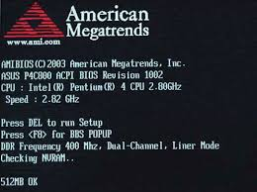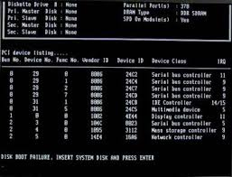

**Figure 2. Display Screen during POST**

when you first turn on your PC or laptop a few screens pop up. It might be a logo such as DELL or HP or ASUS, Tyan, AMI BIOS, AWARD BIOS etc. You might also see a memory count. This is all part of the POST (Power On Self Test).

POST is a test the BIOS runs before it hands over control to the OS (Operating System). It goes through several steps of checking, testing and initializing the hardware components. Before entering each step, the BIOS writes a 2 digit identifying code to an external address. This code is commonly referred to as a POST code.

## **5.0 POST CODES**

The meaning of the codes varies widely. Most computer manufacturers use a BIOS supplied by a third party, the most common are Phoenix and AMI, but there are many others. The codes also vary depending on the motherboard and the manufacturer's requirements.

These codes are useful during the manufacturing process to help identify problems. To the consumer, they are useful in cases where the system won't boot up and the video screen does not work, or if you are attempting to make modifications.

If the BIOS detects a problem, it will stop on the problem, and the last code that was output will indicate what the failure is.

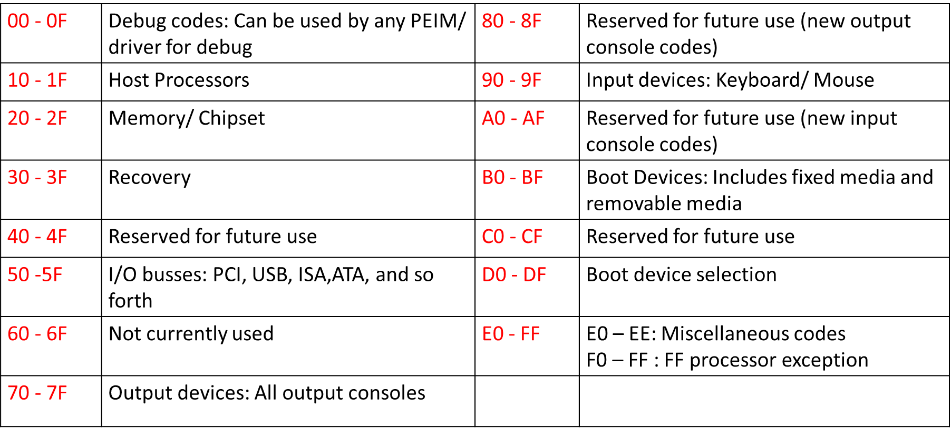

**Figure 3. POST Code range**

### **5.1 Post Code Reader**

In order to see the codes being generated by your BIOS, you will need a Post Code Master Display card, which plugs into your PC and displays these codes as the BIOS performs its tests.

There are versions available for both ISA and PCI motherboard slots. The card displays HEX digits which consist of the numbers 0-9 and the letters A-F. The letters B and D are displayed as lower case (b & d).

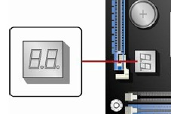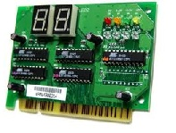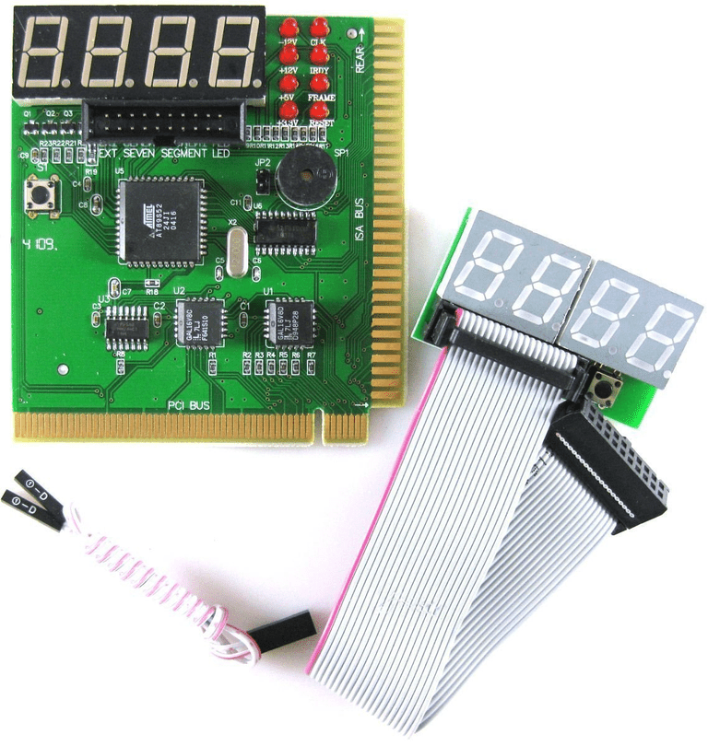

**Figure 4. POST Code Reader**

### **5.2 Displaying POST codes**

You can display POST codes using either of the following methods.

* POST card (PCI add-in card) The POST card decodes the port and displays the contents on an LED display. The POST card must be installed in PCI bus connector 1.
* Onboard POST code LED display Some Intel® Desktop Boards include an onboard LED to show POST codes

### **5.3 How Post Test Cards Work**

Most POST test cards plug directly into expansion slots in the motherboard while a few others connect externally via a parallel or serial port. During the Power On Self Test, a two-digit code is produced and can usually be read on port 0x80. Some POST test cards include jumpers that let you modify which port to read the code from since some manufacturers use a different port. This code is created during each diagnostic step during boot up. After each piece of hardware is identified as working, the next component is checked. If an error is detected, the boot up process usually halts, and the POST test card shows the error code.

Eg. if the POST test card shows the error number 28, and Dell is the BIOS manufacturer, it means that the CMOS RAM battery has gone bad.

### **5.4 Port 80h POST code range**

Typical port 80h POST sequence

Port 80h code values typically increase during the boot process. The early codes are for subsystems closer to the processor and the later codes are for peripherals. Generally, the order of initialization is **Processor -> Memory -> Busses -> Output/Input Devices -> Boot Devices**. The sequence of POST is system-specific.

Besides POST codes, beep codes and POST error messages are also used to detect the error prior to boot up.

**Beep codes**- Beep codes are audible error codes that serve a similar purpose to POST codes, but these errors don't require anything but a working internal speaker - no working screen or any need to open your computer to install and use a POST test card.

**POST error messages** - If the display is working, you may see a POST error message display on the screen. This is just a regular error message like what you'd expect to see at any stage of using your computer. This type of POST error code doesn't require a POST test card either.